Transporter – Integrate IR-Sensors
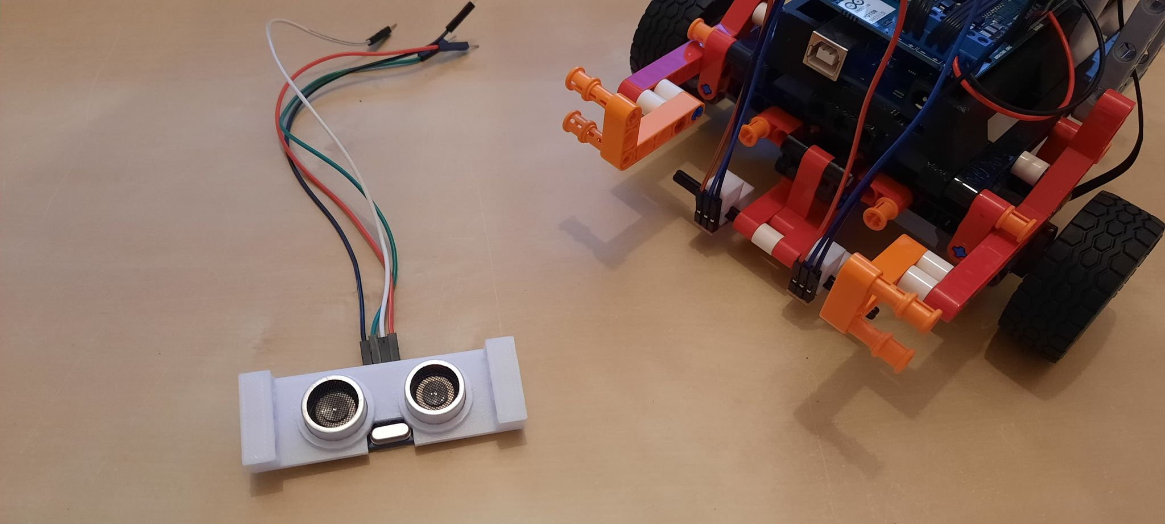
Find an ultrasonic distance-sensor and attach it to the 3D printed module.

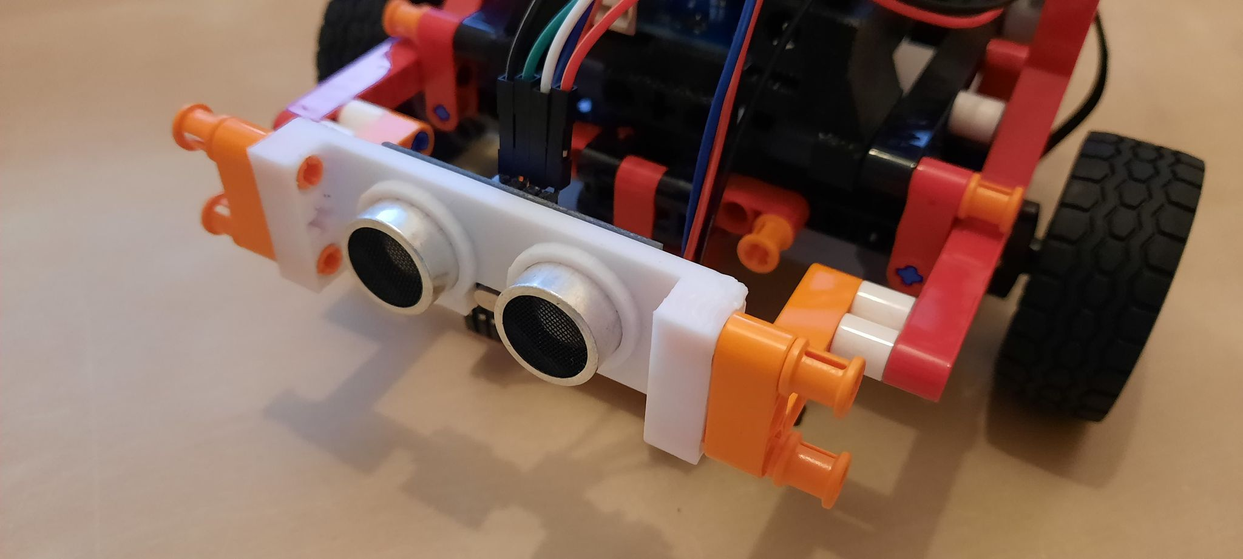
Attach the ultrasonic distance-sensor to the robot.

