Transporter – Integrate the Arduino platform
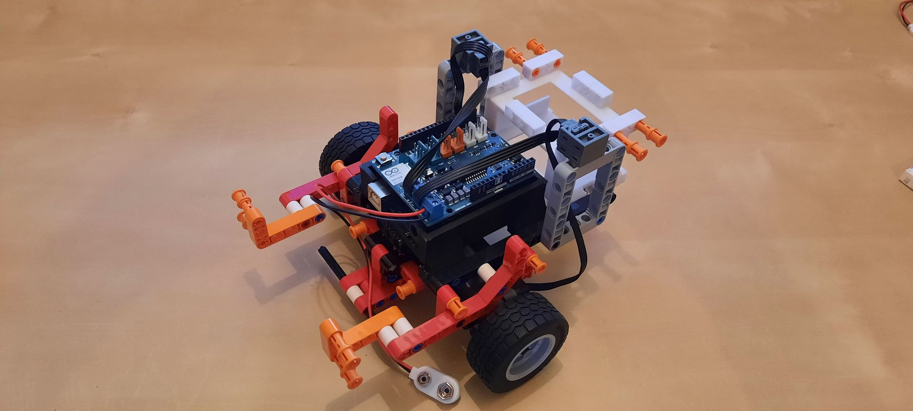
Attach the Arduino R3 Motorshield to the Arduino Uno, and place it on the robot, then connect the cords for the motors and the batteryclip.

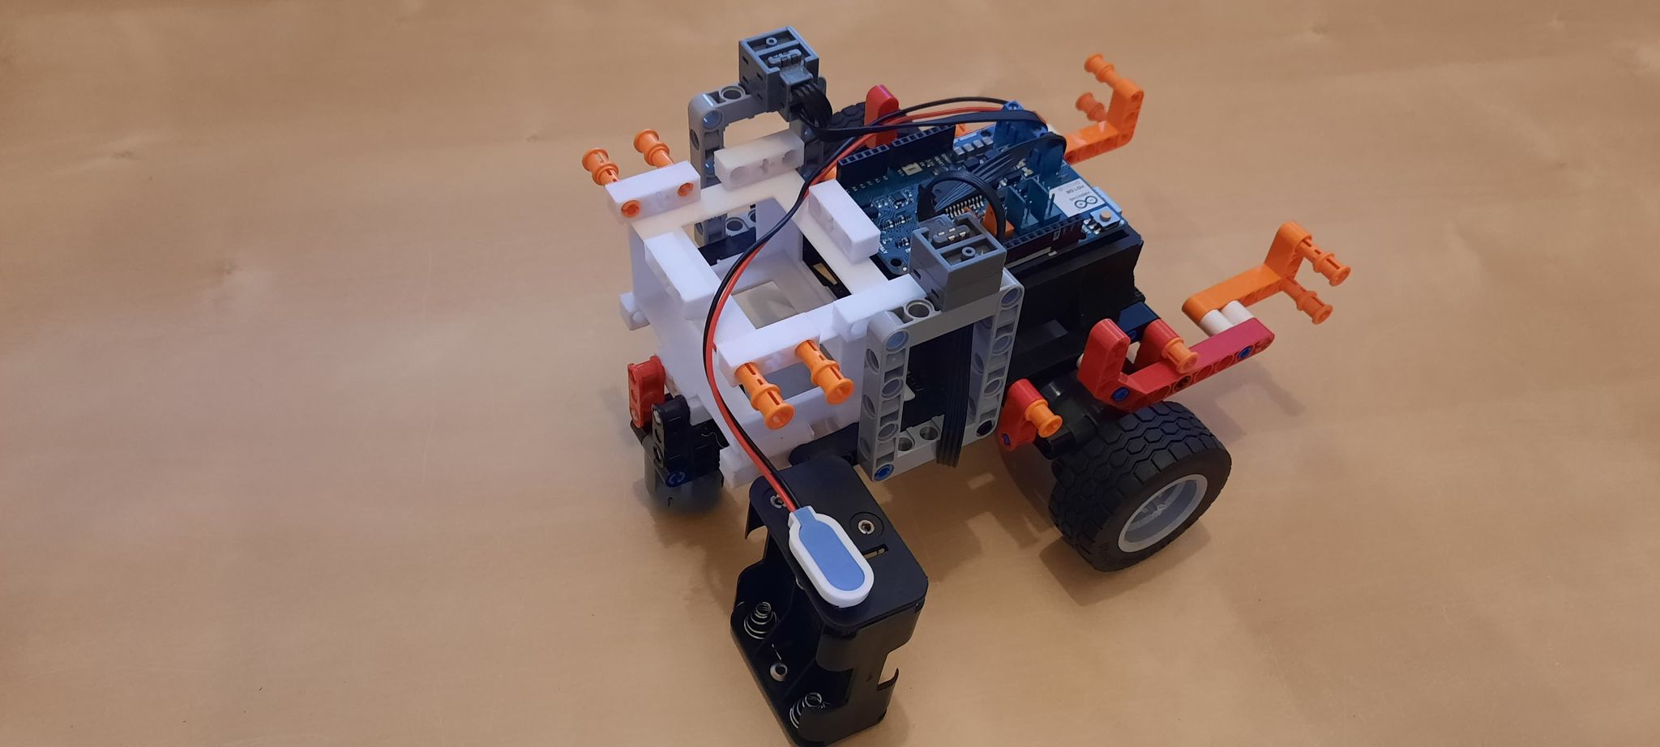
Connect the batteryclip to the cord.
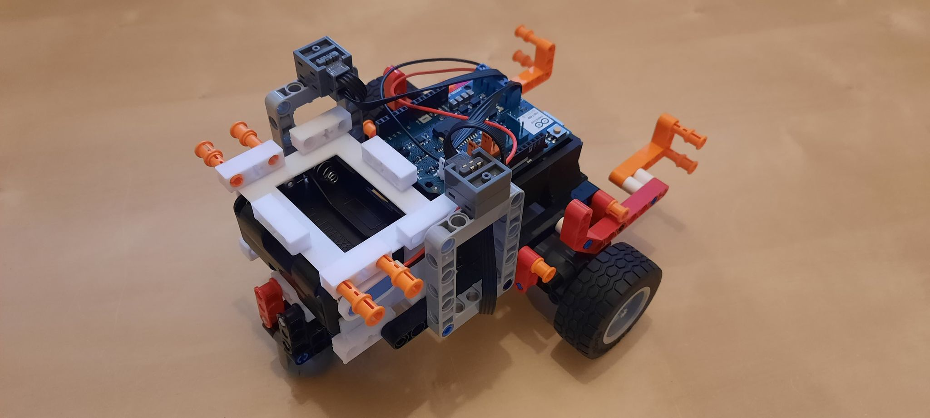
Place the batteryclip inside the robot.

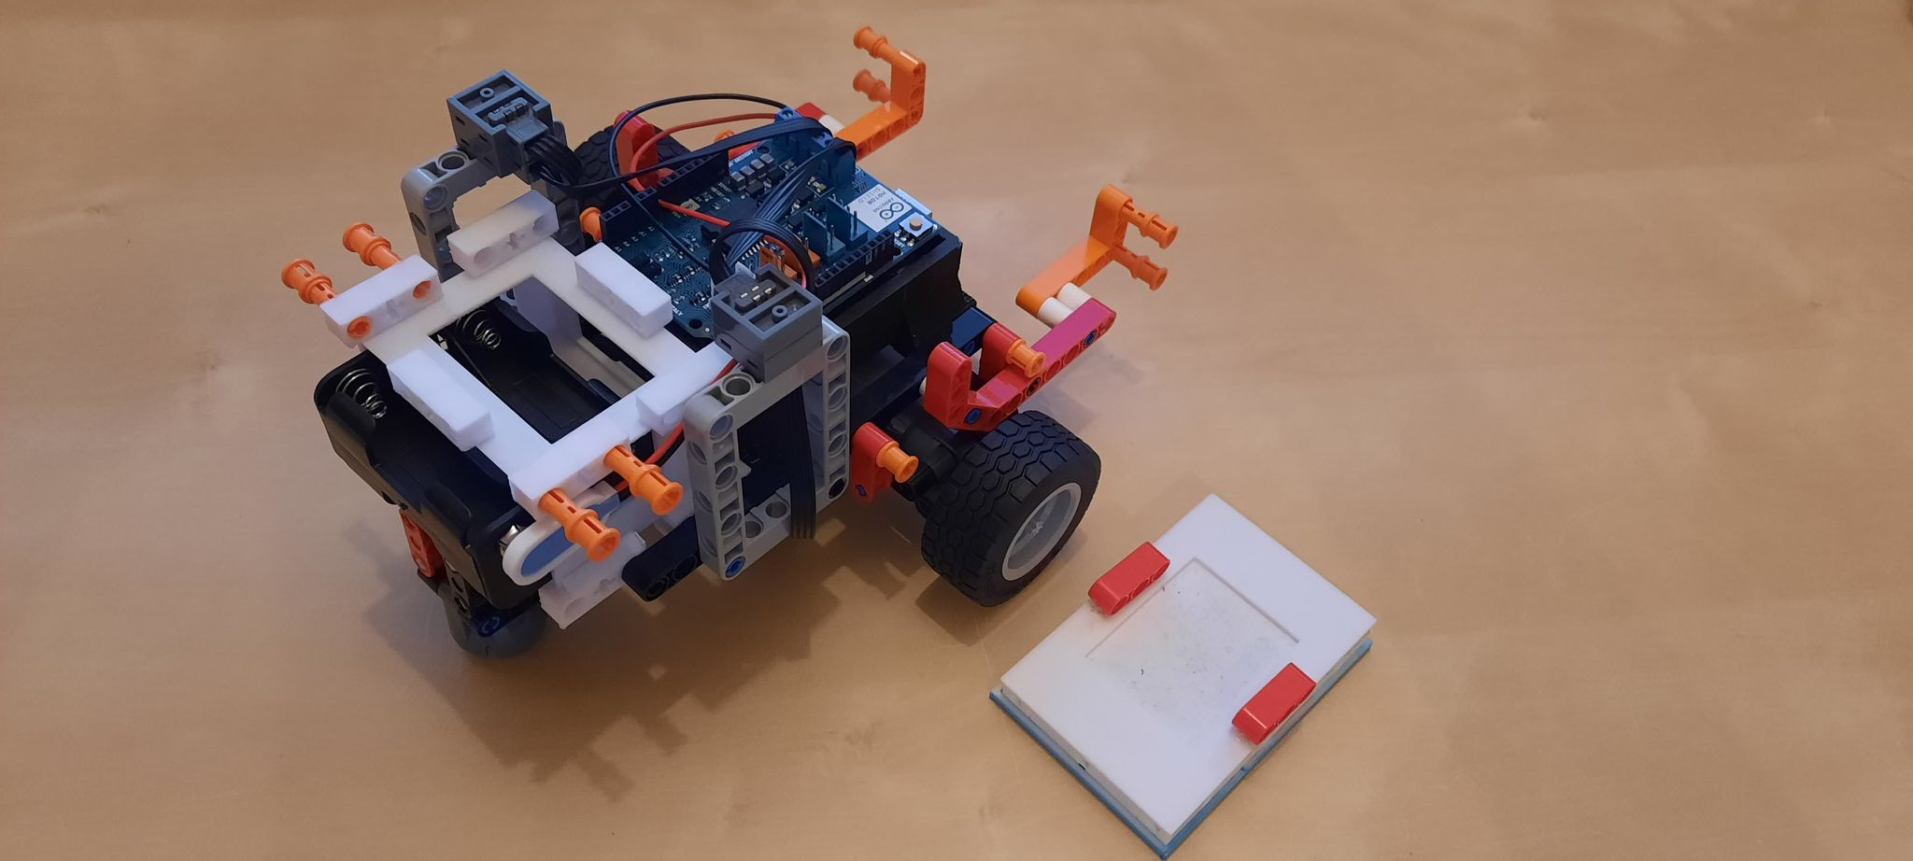
Glue the breadboard on top of the 3D printed breadboard module (note that the module in the image is a prototype, and thus deviates slightly from the one used in this project – it works the same however).

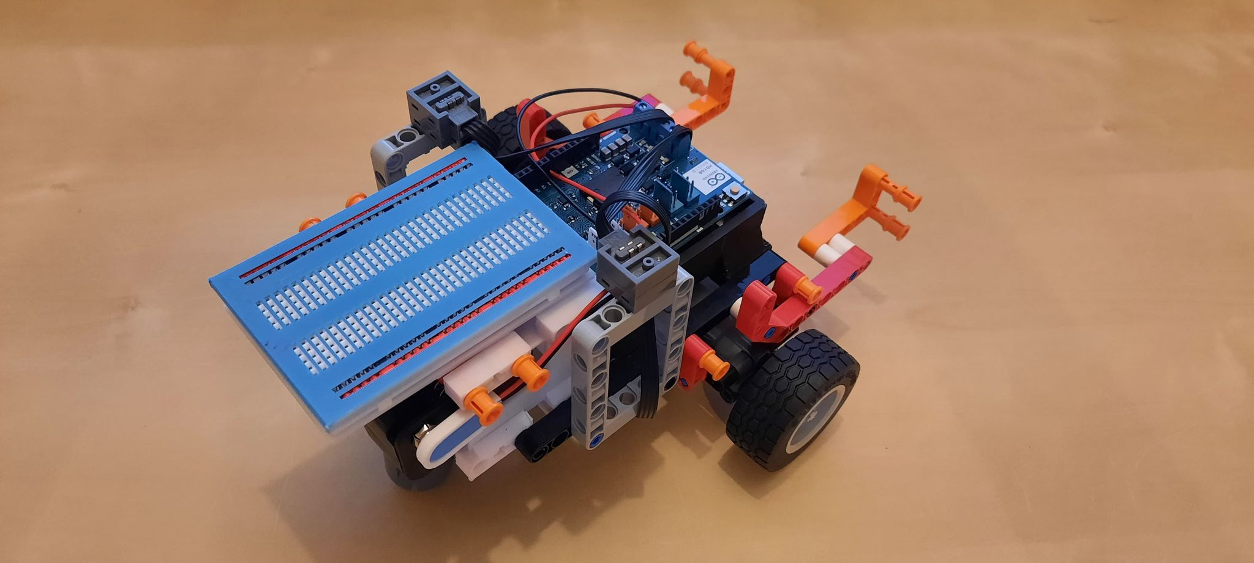
Connect the 3D printed module along with the breadboard, on top of the 3D printed battery holder module, as seen on the image (note that the used breadboard is a prototype, and does not look exactly as a standard breadboard, it works the same however).

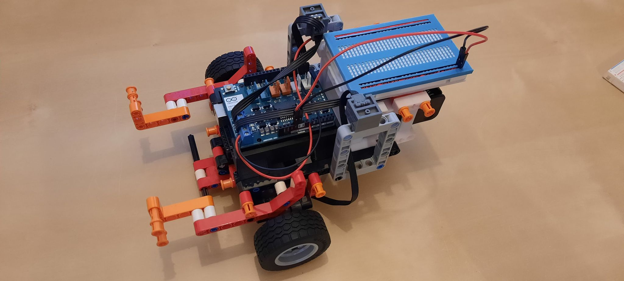
Connect 5V and GND from the Arduino, to the breadboard, using two jumper wires.

